Crop Recommendation System Using AI

|  |  |  |
| --- | --- | --- |
| Aditya Chavan  Electronics And Telecommunications Pune Vidyarthi Griha’s College Of engineering And Technology And G.K. Pate (Wani) Institute Of Management, Savitribai Phule Pune University Pune, India line 5: email address or ORCID | Anushray Pingle  Electronics And Telecommunications Pune Vidyarthi Griha’s College Of engineering And Technology And G.K. Pate (Wani) Institute Of Management, Savitribai Phule Pune University Pune, India line 5: email address or ORCID | Tejas Kulkarni  Electronics And Telecommunications Pune Vidyarthi Griha’s College Of engineering And Technology And G.K. Pate (Wani) Institute Of Management, Savitribai Phule Pune University Pune, India line 5: email address or ORCID |

|  |  |
| --- | --- |
| Prof. Anand Najan  Electronics And Telecommunications Pune Vidyarthi Griha’s College Of engineering And Technology And G.K. Pate (Wani) Institute Of Management, Savitribai Phule Pune University Pune, India line 5: email address or ORCID | Darshan Pakhale  Electronics And Telecommunications Pune Vidyarthi Griha’s College Of engineering And Technology And G.K. Pate (Wani) Institute Of Management, Savitribai Phule Pune University Pune, India line 5: email address or ORCID |

**Abstract:** Farmers can use this workspace- based application, which is important. Inspectors have become continuously fascinated by shore wards orchestrating and its plan all through ongoing years for various reasons. One such system for reviewing the prosperity of soil and land is picture demand. A bewildering assessment thinks about the effects of various components. The assessment of stream that has been proposed around here regions the two its actual limit and the issues it would in everyday explanation. Here, it has been endeavored to consider the parts these methods have guided to chip away at the precision of the depiction. Legitimate usage of how much highlights of in a roundabout way recognized information and picking the best reasonable classifier are generally basic for dealing with the exactness of the get- together. The information - based plan or non-parametric classifier like mind network have acquired ubiquity for multisource information assembling of late. Not with staying, there is right now the level of additional examination, to reduce shortcomings in the improvement of precision of the Image gathering instruments. By utilizing support vector machine calculation is utilized to suggest the yields in view of the dirt. Additionally, we are prescribing the modern data to the rancher.

**Keywords**- **Convolutional Neural Network, Random Forest, K- Nearest Neighborhood, Crop Recommendation System.**

1. **INTRODUCTION**

One of the basic parts to a developing field's ability to make crops is the soil. The presence of data and great judgment conditions guide soil strategy thinking. Social event of soil interfaces soil tests with a couple of kinds of unquestionable substance on the world's property surfaces. requesting soil has transformed into a significantly famous issue in PC vision and picture dealing with. To make the computation as exact as could be anticipated, different new estimations are being made using convolutional structures. The extraction of even pixel-level features is as of now reachable considering the way that to convolutional structures. The target of this endeavor is to create a twofold face classifier that can remove components like edges, assortment, and surface paying little brain to game plan. This survey presents a strategy for definitively requesting soil from input photos of any size. Using different compound properties, CNN techniques recognize soil pictures, and likely reaps for that soil series are proposed using geographic qualities and SVM. An electronic gadget is staggeringly useful to farmers. The farmer will sell taking everything into account. His thing is open online likewise without entering the market during this pandemic.

1. **LITERATURE SURVEY**

Krizhevsky et al. [1] communicated that, significant convolutional cerebrum association to arrange the 1.2 million significant standard pictures in the ImageNet LSVRC-2010 test into the 1000 unmistakable classes. On the test data, we achieved top-1 and top-5 misstep speeds of 37.5% and 17.0% which is widely better contrasted with the past forefront. [2] proposed that developing is done by ordinary system, farmer's plant crops for the most part without knowing the substance of soil and nature of that soil. Consequently, farmers will not get satisfactory advantage starting there developing. The ongoing method for soil testing is manual system what starts by taking soil tests and a while later ship off labs for testing. [3] The goal of the work is to look at different information mining procedures which gives the most ludicrous accuracy. Information mining is just the way that helps with changing over enormous information into degrees of progress and make them open to the ranchers. Al Zaminur Rahman et al. [4] recommended that Soil is a critical component of cultivation. There are a couple of kinds of soil. Each kind of soil can have different sorts of components and different kinds of yields foster on different sorts of soils. We need to know the components and traits of various soil types to fathom which harvests fill better in unambiguous soil types. In this paper, we have proposed a model that can predict soil series with land type and according to assumption it can suggest sensible yields. Dhanush Vishwakarma [5] this system will suggest the best sensible reap for explicit land considering content and climate limits. Also, moreover, the structure gives data about the fundamental substance and measure of composts, required seeds for improvement. Consequently, by utilizing this structure farmers can develop one more variety of yield, may augment in generally income and can avoid soil defilement. Rageena P.M et al. [6] this system accumulates environment data like wetness, proportion of precipitation, temperature, light for each area entered by the client and spreads out two sorts of assumption model to expect the harvest sensible for that area. The Gauge model involves suitable classifier (Sincere Bayesian). Proposed system executes two gather gauge model i.e., Sincere Bayes crop assumption model and Fleecy Guileless Bayes assumption model. Similarly proposed system takes a gander at the precision of two model using confusion network.

**III. PROBLEM STATEMENT**

1] To Design and Implement crop prediction system using convolutional neural network and random forest.

**IV. PROPOSED METHOD AND ALGORITHM**

1. **Proposed Methodology**

With a little assortment of prepared information, we are proposing a trial on soil variety acknowledgment and harvest suggestion in the recommended framework. The System architecture of the proposed model is shown in fig. 1.

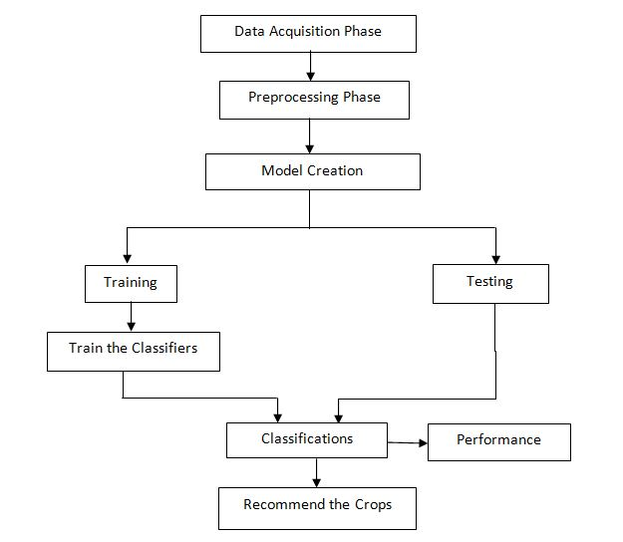

Fig1. Proposed Architecture

A critical number of preparing tests are required for the convolutional brain network utilized for picture grouping.

1. **Dataset**

In our undertaking we require three distinct datasets one is for soil pictures, soil elements, for example, N, P, K, Temperature, Moistness, precipitation and PH and so on lastly shops address. The two datasets we will accumulate structure Kaggle and crops dataset we are gathering from Krishi Utpann Bazzar samiti and shops dataset we are gathering from google.

1. **Pre-processing**

In pre-processing we have resized every image into 224*224.

1. **Data Augmentation**

In this step we are performing some transformations on images such as rotate the Image into 40 degree/angle, zoom the image with 0.2 scale factor and changing the Contrast of original image.

1. **Model Training**

In this step we have trained the model with 20 epochs and we got the **91.6%** accuracy.

1. **Algorithms**

**1. Convolutional Neural Networks(CNN)**

Convolutional Neural Networks (which are furthermore called CNN/ConvNets) are a sort of Fake Brain Organizations that are known to be areas of strength for colossally the field of separating confirmation similarly as picture request. Four principal activities in the Convolutional Brain Organizations are displayed as follows:

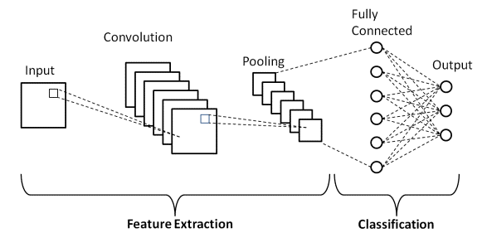

Fig.2 Architecture of CNN

(https://d14b9ctw0m6fid.cloudfront.net/ugblog/wp-content/uploads/2020/12/1-4.png)

(i) Convolution

The standard use of the Convolution activity if there should be an occasion of a CNN is to see fitting highlights from the picture which goes presumably as a guarantee to the fundamental layer. Convolution keeps up the spatial interrelation of the pixels This is finished by fulfillment of picture highlights utilizing miniscule squares of the picture. Convolution condition. Each picture is seen as an association of pixels, each having its own worth. Pixel is the smallest unit in this picture network. License us to take a 5 by 5(5*5) framework whose qualities are just in twofold (for example 0 or 1), for better comprehension. It is to be seen that photographs are by and large RGB with likely gains of the pixels going from 0 - 255 i.e 256 pixels.

ii). ReLU

ReLU circles back to a simple level. With everything taken into account, it is a movement which is applied per pixel and abrogates all of the non-positive potential gains of each and every pixel in the part map by nothing.

(iii). Pooling or sub-sampling

Spatial Pooling which is moreover called sub-testing or down examining assists in diminishing the components of every component with planning yet even simultaneously, holds the most

significant information of the aide. Resulting to pooling is finished, over the long haul our 3D component map is changed over to one layered part vector.

**2. Random Forest**

Arbitrary backwoods are a computer-based intelligence system that is used to deal with backslide and arrange issues. It utilizes outfit understanding, which is a methodology that joins various classifiers to give deals with serious consequences regarding complex issues. An unpredictable woodlands computation involves various decision trees. An irregular timberland calculation comprises of numerous choice trees estimation is ready through firing or bootstrap conglomerating. Pressing is a company meta-estimation that deals with the precision of computer-based intelligence computations. The (unpredictable woodlands) computation spreads out the outcome considering the assumptions for the decision trees. It predicts by taking the typical or mean of the outcome from various trees. Growing the number of trees fabricates the exactness of the outcome.

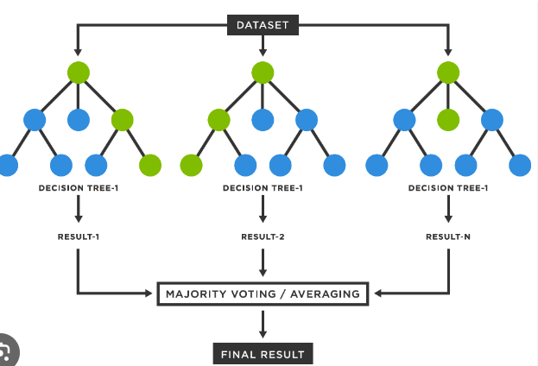

Fig3. Random Forest Architecture

1. **KNN**

KNN A refinement of the k-NN depiction calculation is to quantify the obligation of each of the k neighbors as shown by their distance to the solicitation point, giving more prominent weight to nearer neighbors. The KNN classifier prescribing the businesses to the farmers.

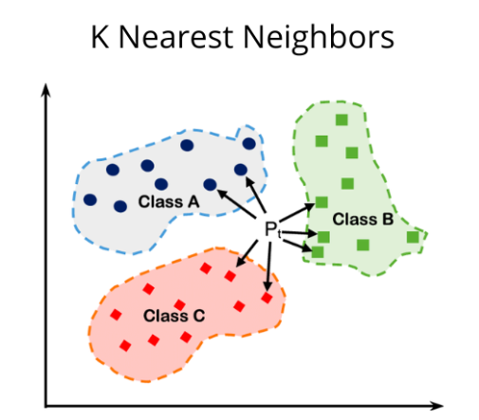

Fig.4 KNN Architecture

d=√((x2-x1) ²+(y2-y1) ²)

d=distance

x1, x2, y1, y2 = data points

**V. RESULTS**

In our experimental setup, as shown in table 1, the total numbers of 650 of trained signals for two categories and 157 new images were tested. These signals go through CNN framework by following feature extraction module. Then our trained model of classification of soil type. Also, we recommend crops using random forest.

Table1. Classification of Data

|  |  |  |
| --- | --- | --- |
| Sr. No. | Category | Number of Images |
| 1 | Training | 105 |
| 2 | Testing | 20 |

Table2. Accuracy Table

|  |  |
| --- | --- |
| Model | Accuracy |
| CNN | 91.69% |
| RF | 89.45% |

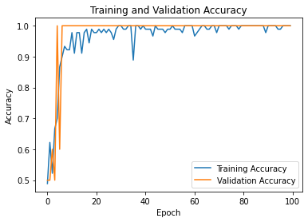

Fig5. Accuracy Graph of CNN

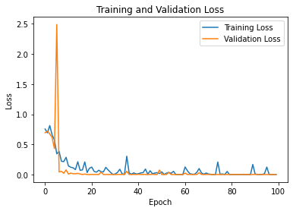

Fig6. Loss Graph of CNN

**VI.** **CONCLUSION**

In this project we recommend the crops using machine learning and deep learning Algorithms and we get the 91.23% accuracy. In this system we will take the image from user and region and based on that we will recommend the crops. Also, we are

recommend the industry to farmer to sell the crops by KNN classifier. In future scope we also work on different types of soil images. Also try to improve the performance of model.

**REFERENCES**

[1] A. Krizhevsky, I. Sutskever and G.E. Hinton, “ImageNet classification with deep convolutional neural networks,” Advances in neural information processing systems, pp. 1097-1105, 2012.

[2] Dharesh Vadalia, Minal Vaity, Krutika Tawate, Dynaneshwar Kapse, “Real Time soil fertility analyzer and crop prediction,” International Research Journal of Engineering and Technology, vol. 04, 2017. [3] Devi, M. P. K., Anthiyur, U., & Shenbagavadivu, M. S. (2016). Enhanced Crop Yield Prediction and Soil Data Analysis Using Data Mining. International Journal of Modern Computer Science, 4(6).

[4] Surili Agarwal, Neha Bhangale, Kameya Dhanure, Shreeya Gavhane, V.A.Chakkarwar, Dr. M.B.Nagori “Application of Colorimetry to determine Soil Fertility through Naive Bayes Classification Algorithm” 9th ICCCNT 2018 July 10-12, 2018, IISC, Bengaluru.

[5] Sk Al Zaminur Rahman, Kaushik Chandra Mitra, S.M. Mohidul Islam “Soil Classification using Machine Learning Methods and Crop Suggestion Based on Soil Series” 2018 21st International Conference of Computer and Information Technology (ICCIT), 21-23 December, 2018.

[6] Dhanush Vishwakarma “Crop Prediction using Machine Learning Approaches” International Journal of Engineering Research & Technology (IJERT).

[7] Rageena P.M et al. “Agriculture Crop Prediction System Based on Meteorological Information” International Journal of Control Theory and Applications ISSN: 0974-5572.

[8] Prof. D.S. Zingade, Omkar Buchade, Nilesh Mehta, Shubham Ghodekar, Chandan Mehta “Crop Prediction System using Machine Learning”.

[9] Ashwani kumar Kushwaha, Swetabhattachrya “crop yield prediction using agro algorithm in hatoop”.

[10] Girish L, Gangadhar S, Bharath T R, Balaji K S, Abhishek K T “Crop Yield and Rainfall Prediction in Tumakuru District using Machine Learning”.

[11] Rahul Katarya, Ashutosh Raturi, Abhinav Mehndiratta, Abhinav Thapper “Impact of Machine Learning Techniques in Precision Agriculture”.

[12] Pijush Samui, Venkata Ravibabu Mandla, Arun Krishna and Tarun Teja “Prediction of Rainfall Using Support Vector Machine and Relevance Vector Machine”.